-: Site System Roles :-
- Site system roles are extra jobs (like distribution point, management point, etc.) you assign to a server so it can help manage devices.
- You add these roles in Configuration Manager to extend what the server can do.
Steps to Add Site System Roles :-
Add roles to an existing server
- Open Configuration Manager console, go to the Administration workspace.
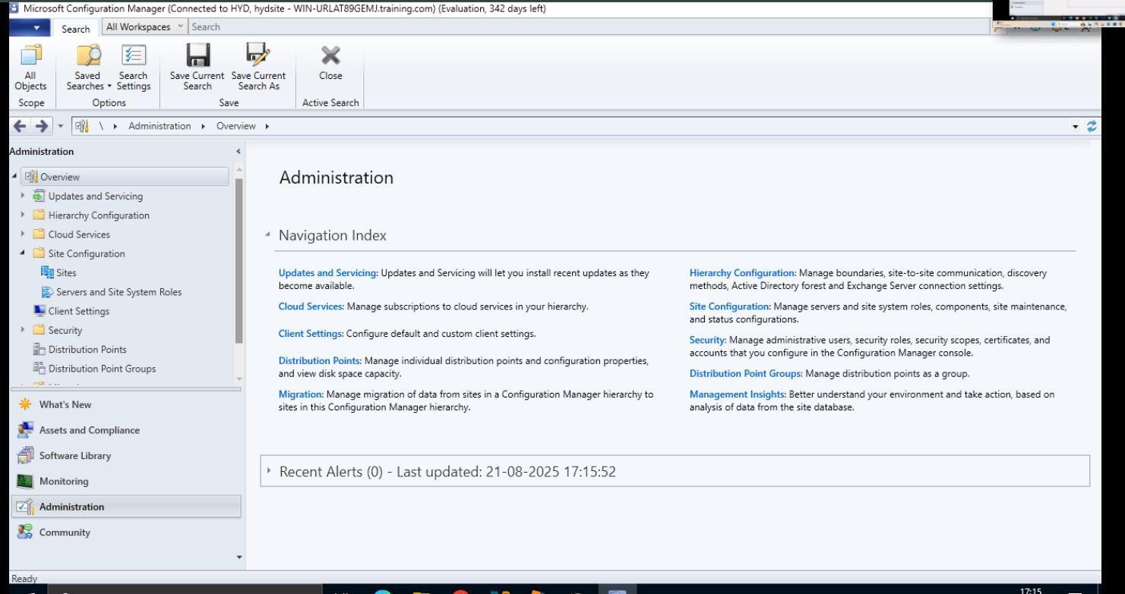
- Navigate through Site Configuration → Servers and Site System Roles.
- Select the server you want to use.
- On the ribbon’s Home tab, click Add Site System Roles.
- General window: review and confirm the server settings (e.g., name, FQDN).
- Proxy page: if needed, enter proxy server details for internet access.
- System Role Selection: tick the roles you want to install (e.g., distribution point, management point, etc.).
- Click Next through any additional pages that appear (role-specific options will be shown).
- Finish the wizard to apply the roles.

Add roles on a new server
- In the same Configuration Manager console → Administration workspace.
- Go to Site Configuration → Servers and Site System Roles.
- On the ribbon’s Create group, click Create Site System Server.
- In the General page: specify the new server’s name and the site where it belongs. Microsoft Learn+1
- Continue with the Proxy settings (if necessary).
- Choose the roles on the System Role Selection page.
- Complete the wizard, including any extra configuration steps for each role. Microsoft Learn+1

Summary Table
Scenario | Navigation Steps
Existing server | Administration → Site Configuration → Servers and Site System Roles → Select server → Add Site System Roles
New server | Administration → Site Configuration → Servers and Site System Roles → Create Site System Server → Follow steps

